AI WeatherWise - Deliver intelligent weather forecasts and insights.

Team ID : SWTID-2026-8226 Team Size : 5

Team Leader : | Thenmozhi V
Team member : | Varshitha D
Team member : | Suji M
Team member : | Sujatha K
Team member : | Subha K

Description

AI WeatherWise is a RESTful backend application developed to provide weather information together with AI-powered explanations and recommendations.
The system is developed using Node.js and Express.js as the backend technologies, while
MongoDB with Mongoose is used for storing application data. The application also integrates Google Gemini AI to convert weather information into understandable summaries and useful recommendations.
The backend provides APIs for user authentication, favorite-location management, weather retrieval, and AI-based weather insights. Security is handled through JWT authentication and bcrypt password hashing.
The application also includes error-handling mechanisms, request validation and sanitization, and fallback functionality so that selected API operations can continue even when an external API key is unavailable.

Scenario-Based Case Study

Background

Alex is a frequent traveler who visits different cities for personal and professional purposes. Before travelling or planning outdoor activities, Alex needs to know the current weather conditions of the destination.Especially when the user wants to maintain a list of frequently visited cities.
AI WeatherWise provides a centralized backend where users can save their preferred locations, retrieve current weather information, and obtain AI-generated suggestions based on environmental conditions.

Problem
Traditional weather applications generally provide numerical weather information such as temperature, humidity, wind speed, and weather conditions. However, users may still need to interpret these values themselves.

- Difficulty in maintaining multiple favorite weather locations.
- Lack of personalized suggestions based on weather conditions.
- Difficulty understanding raw weather measurements.
- Requirement for natural-language weather summaries.
- Need for a centralized backend to manage weather and AI services.

Solution
The AI WeatherWise provides a centralized service that handles weather data retrieval and AI orchestrations. It manages a secure User and Location database, allowing for customized insights and automated recommendation workflows through Google Gemini.

Usage
- Register and authenticate securely.
- Store multiple favorite cities.
- Add, update, view, and remove saved locations.
- Retrieve current weather information.
- Generate AI-based weather summaries.
- Receive recommendations for activities and suitable clothing.
- Manage their account securely.
- Access weather information through REST APIs

Outcome
By leveraging AI and centralized data management, users spend less time deciphering raw metrics. The system ensures data integrity via Mongoose schemas and provides high-value, context-aware weather advice through Gemini integrations.Instead of requiring users to interpret every weather measurement individually, the system can provide meaningful descriptions and recommendations through Gemini AI.

1. Software Requirements
The following software components are required to develop and execute the AI WeatherWise backend ● Operating System: Windows 10/11, macOS, or Linux (supports cross-platform operations).
- Node.js (v16 or above): Runtime ecosystem running server logic and routing infrastructure.
- npm (v8 or above): Node package manager to control operational dependencies.
- Gemini AI SDK: Integration using @google/generative-ai for natural language insights.
- MongoDB: Document NoSQL engine storing users, posts, categories, comments, and analytics metrics.
- Postman: API verification toolkit to assert schema validation responses across administrative route shields.
- Code Editor: Visual Studio Code or similar IDE environment.

2. Hardware Requirements
- Processor: Intel Core i5 (8th Gen or above) / AMD Ryzen 5 or equivalent.
- RAM: 8 GB minimum (16 GB recommended for concurrent instances of MongoDB, processing layers, and execution nodes).
- Storage: 1 GB of available disk workspace.

Epic 1: PROJECT ARCHITECTURE

The AI WeatherWise application follows the MVC pattern to decouple business logic from data management.
The Controller layer orchestrates weather fetching from OpenWeatherMap and generation of AI insights via Gemini, while the Model layer manages User and Location entities.

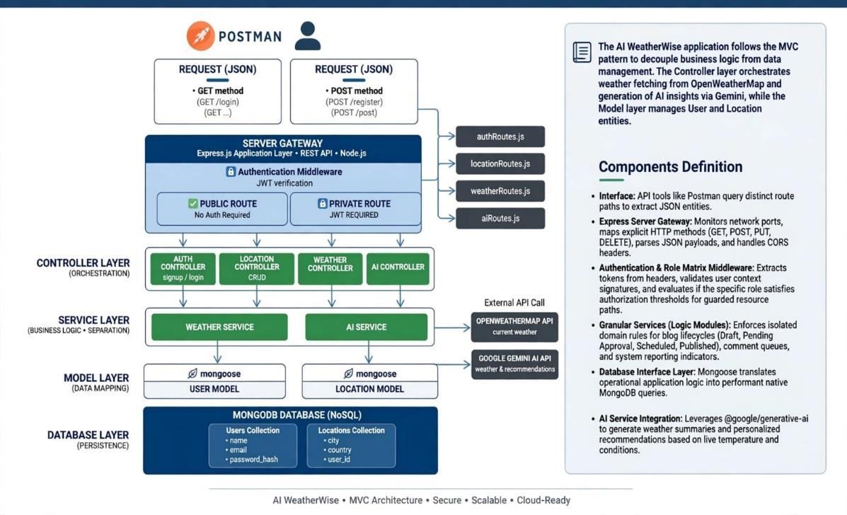

Components Definition
- Interface: API tools like Postman query distinct route paths to extract JSON entities.
- Express Server Gateway: Monitors network ports, maps explicit HTTP methods (GET, POST, PUT, DELETE), parses JSON payloads, and handles CORS headers.
- Authentication & Role Matrix Middleware: Extracts tokens from headers, validates user context signatures, and evaluates if the specific role satisfies authorization thresholds for guarded resource paths.
- Granular Services (Logic Modules): Enforces isolated domain rules for blog lifecycles (Draft, Pending Approval, Scheduled, Published), comment queues, and system reporting indicators.
- Database Interface Layer: Mongoose translates operational application logic into performant native MongoDB queries.
- AI Service Integration: Leverages @google/generative-ai to generate weather summaries and personalized recommendations based on live temperature and conditions.
The AI WeatherWise technical architecture combines a three-tier system structure with MVC-based backend organization. Node.js and Express.js manage API processing, MongoDB and Mongoose provide persistent storage, JWT and bcrypt support security, OpenWeatherMap provides weather data, and Gemini AI provides intelligent weather insights. The separation of client, business logic, data, routing, controllers, models, middleware, and services provides a clear and maintainable structure for the project and supports future extension.

Technical Architecture - Sub Topics

OBJECTIVES OF THE PROJECT

AI WeatherWise is a RESTful backend application developed to provide weather information together with AI-powered explanations and recommendations. The system uses Node.js and Express.js for backend development, MongoDB with Mongoose for data persistence, and Google Gemini AI for generating understandable weather summaries and recommendations. The backend also provides user authentication, favorite-city management, weather retrieval, request validation, error handling, and JWTbased security.

1 .SYSTEM ARCHITECTURE

The main objectives of AI WeatherWise are to provide a centralized weather information service, securely manage registered users and favorite cities, retrieve current weather data through an external weather API, generate AI-based summaries and recommendations, maintain persistent application data using MongoDB, and provide a modular and maintainable backend architecture.

1.1 Client Tier / Frontend
The Client Tier provides the interface through which users interact with the AI WeatherWise backend and consume its REST API services. It is responsible for collecting user inputs, sending HTTP requests to the appropriate backend routes, and displaying the JSON responses returned by the application. For API development and verification, Postman can be used as the client interface to test authentication, favoritecity management, weather retrieval, and AI insight endpoints.
The client tier communicates with the Express.js backend through defined API endpoints. User actions such as registration, login, saving a favorite city, requesting current weather, or obtaining an AI-generated recommendation are converted into API requests. The backend processes these requests and returns structured JSON responses, which the client can present to the user in an understandable form.
The client tier may be implemented using React.js, HTML5, CSS3, and JavaScript for a web-based interface. It also supports input validation and appropriate handling of successful and error responses from the backend. For protected operations, the client sends the JWT received after authentication so that the backend can validate the user's access before processing the request.

1.2 Business Logic Tier / Backend

The Client Tier provides the user-facing interface or API client through which requests are sent to the backend. React.js, HTML5, CSS3, and JavaScript can be used for the frontend, while Postman can be used for API testing. Its main functions are user interaction, form validation, and API consumption.

1.3 Data Tier / Database

The Business Logic Tier is implemented using Node.js and Express.js. It receives HTTP requests, applies middleware, performs authentication and authorization, executes application logic, communicates with external weather and AI services, and prepares JSON responses. Mongoose acts as the ODM between the application and MongoDB.

2. DATABASE DESIGN AND SCHEMA

The Data Tier uses MongoDB Atlas as the cloud database. Data is stored as BSON documents organized into databases, collections, and documents. The database stores user information, favorite locations, weather cache information, and other persistent application data.

3. DATA FLOW DIAGRAM

The database design mainly connects users with their saved locations and weather-related information.
The core collections are users, favorites or locations, and weatherCache. The users collection can contain _id, name, email, password, and role. The favorites/locations collection can contain _id, userId or user, cityName or city, country, and createdAt. The weatherCache collection can store weather information, city identifiers, timestamps, and the optional aiSummary. The relationship between a user and saved locations is one-to-many using MongoDB ObjectId references. Mongoose schemas provide data type validation and structural rules.

4. MODULES AND FUNCTIONALITIES

Level 1: User Request → Express Router → Authentication Middleware where required → Controller / Service → Mongoose Model or External API → Processing → JSON Response.

Level 0: User / Client → AI WeatherWise Application → MongoDB Atlas / External Weather Service / Gemini AI → Application → User / Client.

4..1 User Authentication Module
The User Authentication Module provides secure registration and login functionality for AI WeatherWise users. During registration, the user's basic details are validated and stored in the MongoDB database through the Mongoose model. Passwords are protected using bcryptjs before they are stored, so the original password is not saved directly in the database.
During login, the system retrieves the user record and verifies the submitted password against the stored hashed password. After successful verification, the backend generates a JSON Web Token (JWT). The token is returned to the authenticated user and is used to access protected API routes. Requests to protected resources pass through JWT middleware, which validates the token and identifies the authenticated user before allowing the controller or service to continue processing the request.
The module therefore provides the authentication flow: User Registration/Login → Validation → MongoDB User Record → Password Verification → JWT Generation → Protected API Access. This approach supports secure account access and helps prevent unauthorized use of protected weather, favorite-city, and account-management operations.

4.2 Favorite City Management Module

Handles user registration and login using MongoDB, bcrypt/bcryptjs, and JWT. User records are created and retrieved through database operations such as insertOne() and findOne() or their Mongoose equivalents.

4.3 Real-Time Weather Data Integration

Allows authenticated users to save and manage favorite cities. The module uses a one-to-many relationship between users and favorite locations. A representative endpoint is POST /api/favorites.

4.4 AI-Driven Insights Module

Retrieves current weather metrics using the configured OpenWeatherMap API integration with Node.js and Axios. A representative endpoint is GET /api/weather?city=. Weather results may be cached in the weatherCache collection.

4.5 Security and JWT Validation Layer

Uses Google Gemini AI to transform weather measurements into natural-language summaries and recommendations. The generated aiSummary can be stored or refreshed in the weather cache using updateOne() or an equivalent Mongoose update operation.

4.6 CRUD Operations

Acts as a common middleware layer for protected APIs. It validates the JWT, extracts the userId, allows authenticated access, and returns JSON responses. Invalid or missing tokens result in HTTP 401 Unauthorized.

5. TECHNOLOGY STACK

The backend supports Create, Read, Update, and Delete operations for applicable stored resources, particularly favorite locations and other persistent application records.

6. SECURITY AND PERFORMANCE

Frontend / Client: React.js, HTML5, CSS3, JavaScript.
Backend: Node.js and Express.js.
Database: MongoDB Atlas with Mongoose ODM.
Authentication and Security: JWT and bcrypt/bcryptjs.
External Services: OpenWeatherMap for weather data and Google Gemini for AI insights.
Tools: Visual Studio Code, Postman, npm, Git/GitHub, and Nodemon. Configuration: dotenv for environment variables.

ADVANTAGES OF THIS ARCHITECTURE

- Security is implemented through JWT authentication, bcrypt password hashing, protected routes, environment variables for sensitive configuration, request validation and sanitization, and suitable MongoDB Atlas access controls.
- Performance can be improved through database indexing, connection pooling, caching of weather responses, and efficient use of external API calls.
- Caching helps reduce repeated requests to the weather service and can improve response time for frequently requested cities.
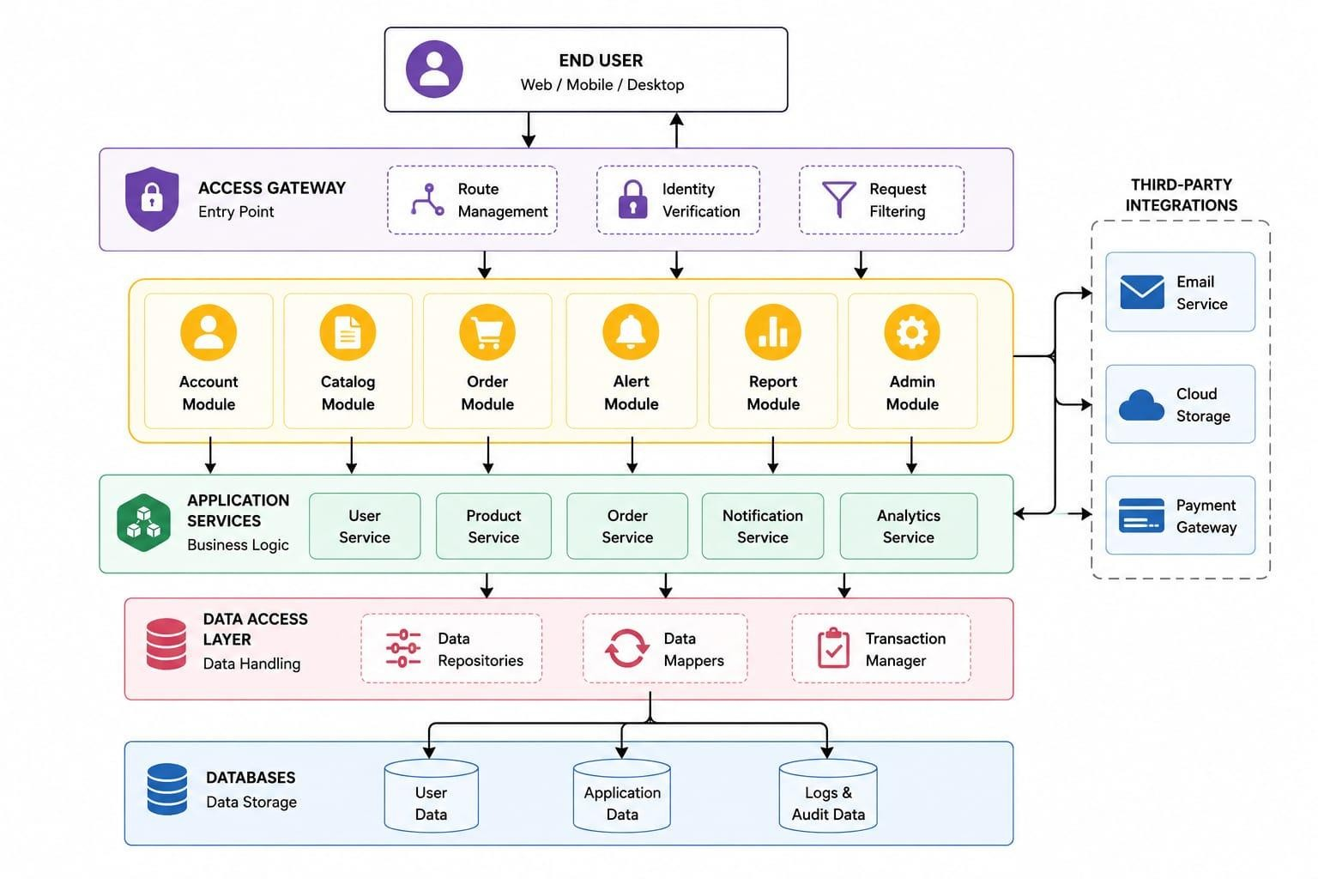

Entity-Relationship (ER) Diagram Description

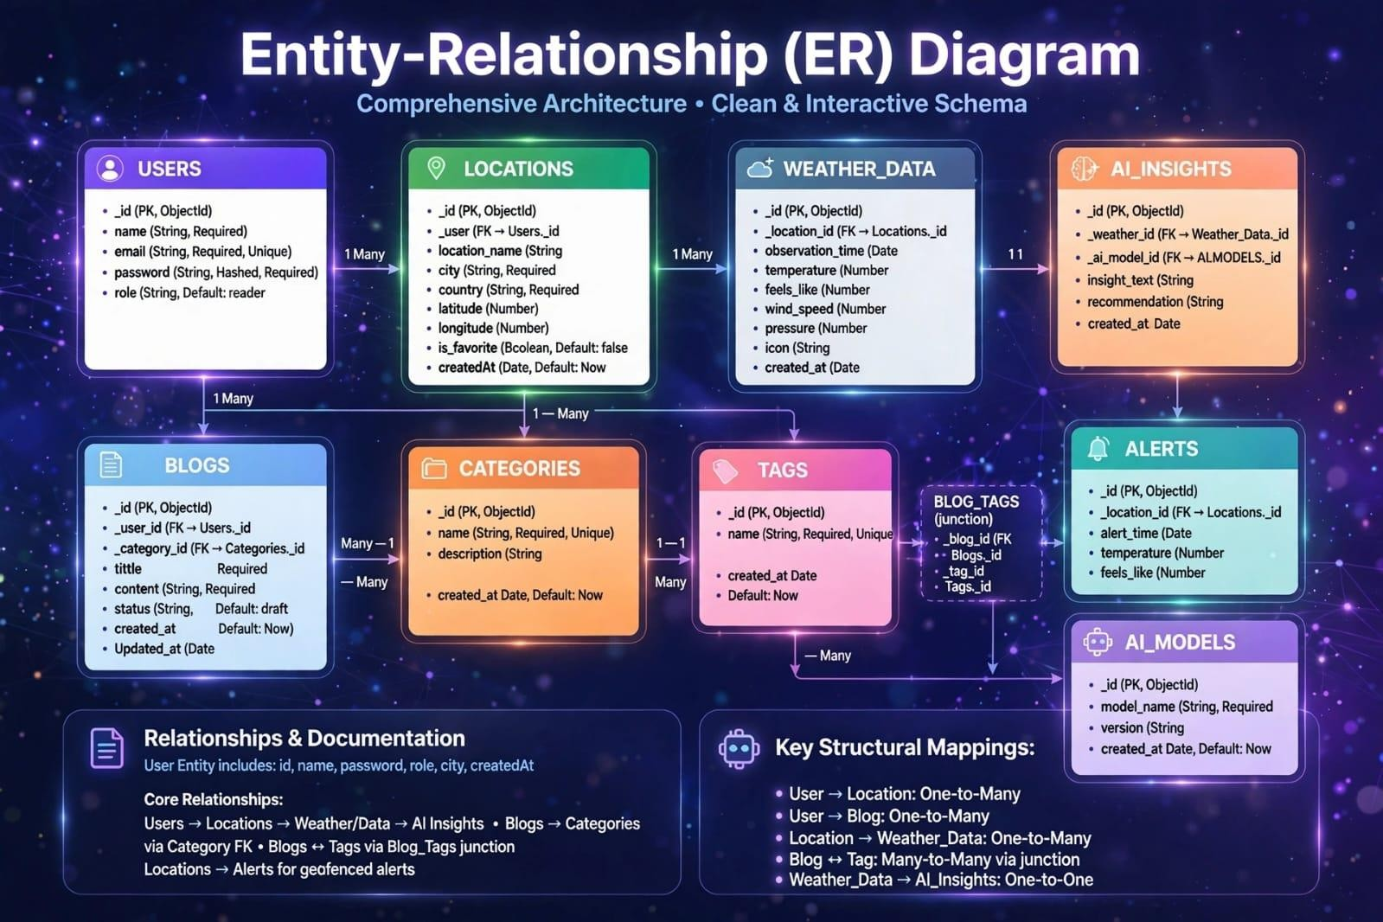

User Entity
- _id (Primary Key - ObjectId)
- name (String, Required)
- email (String, Required, Unique)

Location Entity
- _id (Primary Key - ObjectId)
- name (String, Required)
- address (String, Required)
- city (String, Required)
- state (String, Required)
- country (String, Required)
- latitude (Number, Required)
- longitude (Number, Required)
- createdAt (Date, Default: Current Date)
- updatedAt (Date, Default: Current Date)
- password (String, Hashed, Required)
- role (String, Default: "reader")

Key Structural Mappings

Many-to-Many Relationship
A many-to-many relationship occurs when multiple records in one entity are associated with multiple records in another entity. For example, in a student management system, many students can enroll in many courses, and each course can have multiple students.

Key Features
- Role-Based Access Control: Restricts system access based on user roles and permissions.
- CRUD Operations: Supports creating, reading, updating, and deleting database records.
- Data Management System: Organizes and maintains structured data for efficient storage and retrieval.
- Query Optimization: Improves database performance through efficient query execution.
- Authentication and Authorization: Ensures secure user verification and controlled access to system resources.
- Data Validation and Sanitization: Prevents invalid inputs and protects against common security vulnerabilities.
- Error Handling Mechanism: Detects, manages, and reports system errors to ensure reliable execution.
- Database Integrity: Maintains data accuracy and consistency through constraints and validation rules.

User Flow

1. User Registration and Login
The user registers an account or logs in using their credentials. The request is sent through the Express API to the authentication controller, where the credentials are validated, the password is securely handled with bcrypt, and a JWT is generated for authenticated access.
Flow: User → Express API → Authentication Controller → MongoDB → JWT Response

2. Favorite City Management
After authentication, the user can add, view, update, or remove favorite cities. Protected requests pass through JWT middleware before the controller performs the required database operation through the Mongoose model.
Flow: User → JWT Middleware → Favorite Route → Controller/Service → Mongoose → MongoDB → JSON Response

3. Real-Time Weather Retrieval
The user requests current weather information for a selected city. The controller/service layer communicates with the configured OpenWeatherMap API, processes the returned weather data, and may use the weather cache to reduce repeated external API requests.
Flow: User → Weather Route → Controller/Service → OpenWeatherMap / Weather Cache → JSON Response

4. AI-Driven Weather Insights
The weather information can be passed to the Gemini AI service to generate an understandable summary, activity guidance, and clothing recommendations. The resulting AI summary may be stored or refreshed in the weather cache.
Flow: Weather Data → AI Service (Gemini) → AI Summary/Recommendations → Cache (optional) → User Response

5. Account and Secure Access
Authenticated users can manage their account information through protected APIs. JWT validation identifies the authenticated user, while authorization and validation checks help prevent unauthorized or malformed requests.
Flow: User → Protected API Route → JWT Middleware → Controller/Service → MongoDB → JSON Response
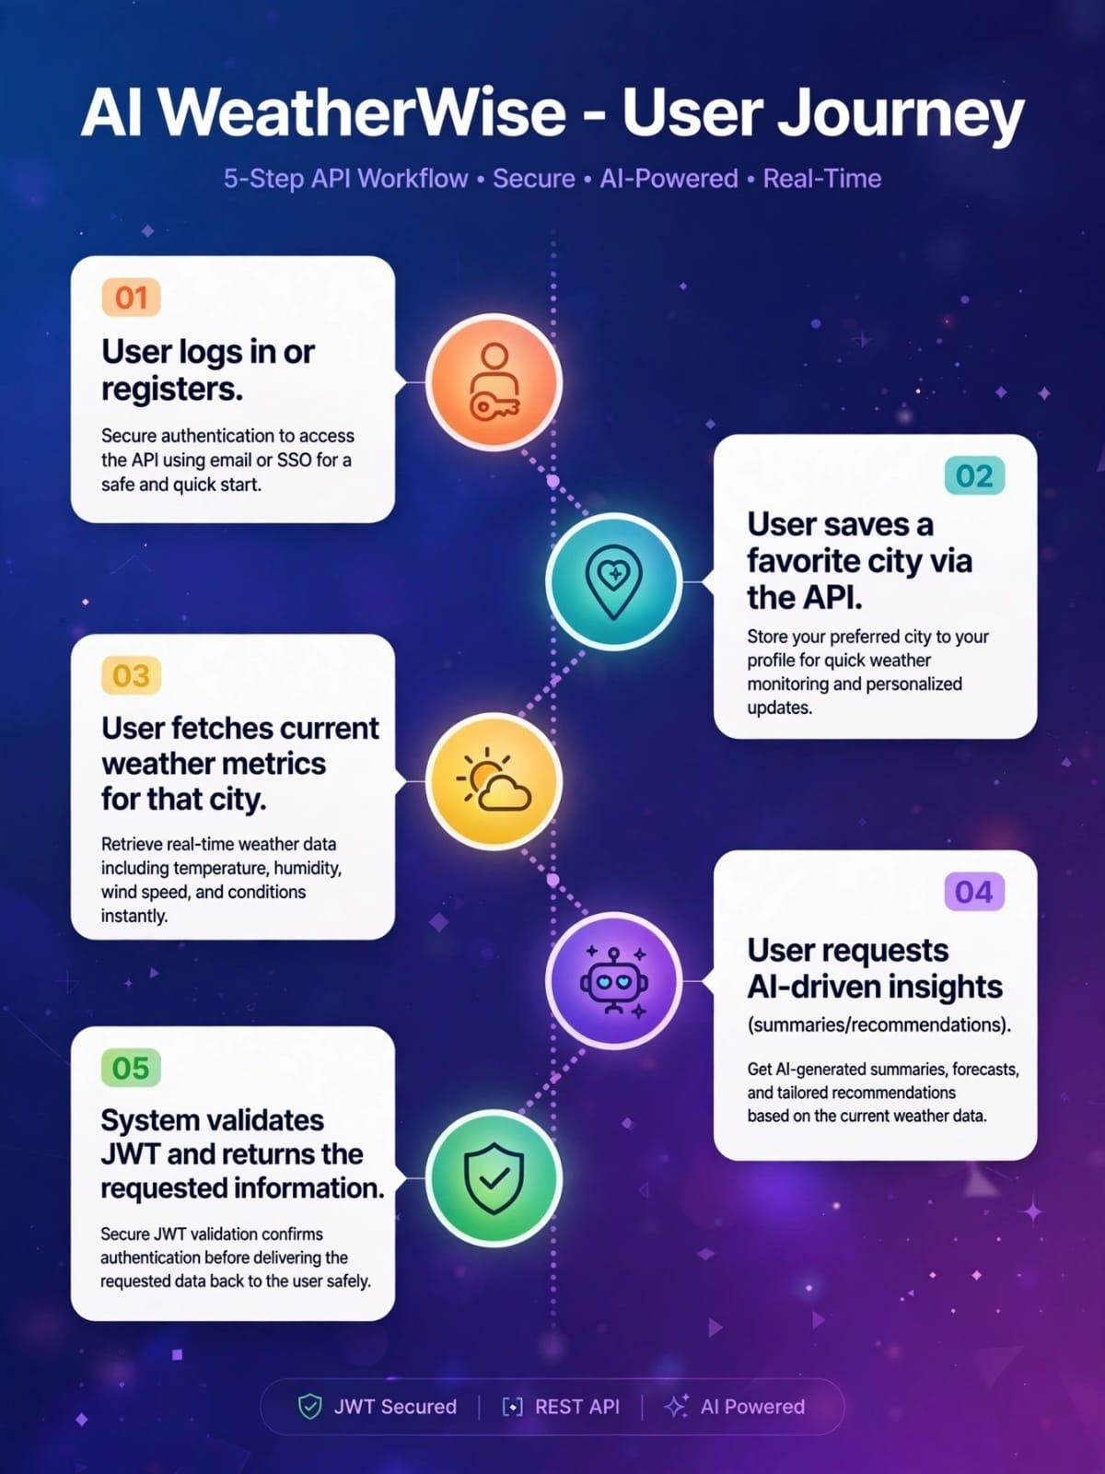

Roles and Responsibilities
Admin:
- Responsible for user account management, including creating, updating, and deleting accounts.
- Monitoring system performance, server health, and application logs.
- Managing database integrity, security, and access permissions.
- Overseeing data backup and system maintenance.
Registered User:
- Responsible for creating and maintaining a personal account.
- Accessing system features and submitting data requests.
- Managing profile details and authentication credentials.
- Retrieving, viewing, and updating personal information.
- Interacting with the application to access availabe

MVC Architecture Pattern
The system architecture structures its source configuration layers around the Model-ViewController design pattern to completely decouple components:

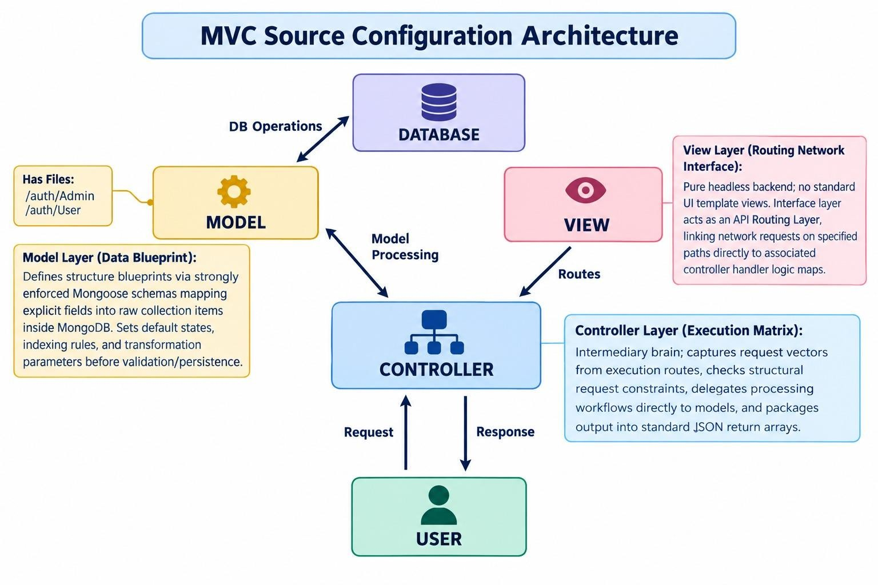

Model Layer (Data Blueprint)
Defines structure blueprints via strongly enforced Mongoose schemas mapping explicit fields into raw collection items inside MongoDB. It sets default states, indexing rules, and transformation parameters before validation persistence occurs.
Definition to write: Defines structure blueprints via strongly enforced Mongoose schemas mapping explicit fields into raw collection items inside MongoDB.
DB Operation: insertOne, findOne, updateOne
Tech: Mongoose Schema
Work: Database structure defines file/models/User.js, /models/Admin.js

Controller Layer (Execution Matrix)
The intermediary brain of the ecosystem. It captures request vectors from the execution routes, checks structural request constraints, delegates processing workflows directly to models, and packages the resultant output into standard JSON return arrays.
Definition to write: The intermediary brain of the ecosystem. It captures request vectors from routes, checks constraints, delegates work to models, and packages the resulting data into standard JSON responses.
Flow: USER Request -> VIEW (Routes) -> CONTROLLER -> MODEL -> DATABASE -> Response
Definition to write: In this pure headless backend, standard UI views do not exist. Instead, it lives as an API Routing Layer that links network requests on specified paths directly to controller logic.
Example: router.post('/register', registerUser)
Tech: Express.js Router
Work: User kudukura request ah vaangura gate
File: /routes/ - Routes folder
Tech: Node.js + Express.js
Work: Brain of the system. Full logic File: /controllers/ - Controllers folder

View Layer (Routing Network Interface)

In this pure headless backend service context, standard user-interface template views do not exist. Instead, the interface layer lives as an API Routing Layer. It links network requests on specified paths directly to their associated controller handler logic maps.
The integrated architecture combines three-tier separation, MVC responsibilities, user-flow modules, database references, external weather integration, AI processing, and JWT security. This organization keeps the backend modular, maintainable, and extensible while preserving a clear request-to-response path.

Epic 2: Project Setup and Configuration

Creating the Project Folder
- Create a new folder named AI Weatherwise
- Open the project folder in Visual Studio Code.
- Initialize the project using Node.js and install the required dependencies.

1. CREATING THE PROJECT FOLDER
The first step in developing the AI WeatherWise API is to create a dedicated project folder. This folder contains all the source code, configuration files, dependencies, database-related files, and backend modules required for the application.

Project Folder Creation
A new folder named “AI WeatherWise” is created on the development system. The folder is then opened in Visual Studio Code so that the complete backend project can be developed and managed in one place.

Initializing the Node.js Project
After opening the project folder in the terminal, the Node.js project is initialized using the following command:
npm init -y

This command creates the package.json file. The package.json file contains the project name, version, scripts, and information about the packages required by the backend.

Installing Backend Dependencies
The required Node.js packages are installed to provide the core functionality of the AI WeatherWise API.
- Express.js – Used to create the REST API server.
- Mongoose – Used to connect and work with MongoDB.
- bcryptjs – Used for secure password hashing.
- jsonwebtoken – Used for JWT-based authentication.
- cors – Used to enable controlled cross-origin requests.
- dotenv – Used to load configuration values from environment variables.
- @google/genai – Used to integrate Google Gemini AI capabilities.
The dependencies can be installed using:
npm install express mongoose bcryptjs jsonwebtoken cors dotenv @google/genai

Development Dependency
Nodemon can be installed as a development dependency. It automatically restarts the server whenever code changes are detected.
npm install --save-dev nodemon

2. SERVER SETUP

The AI WeatherWise backend server is developed using Node.js and Express.js. Express acts as the main server framework and handles client requests, API routes, middleware, and responses.
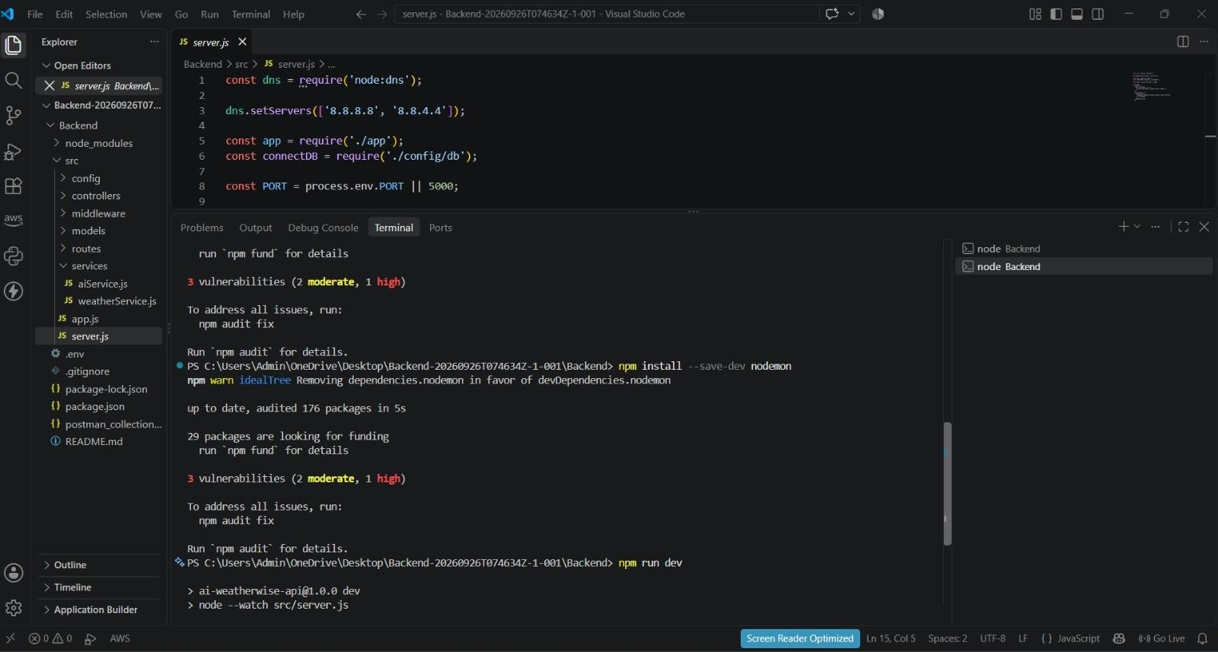

Creating the Express Server :

The main server file, such as index.js, is created in the project root directory. It acts as the entry point of the backend application.

Server Configuration
The server is configured to load environment variables, initialize Express, enable JSON request processing, configure CORS, connect to MongoDB, register API routes, and start listening on the configured port.
Basic server execution flow:
- Start the Node.js application.
- Load environment variables.
- Initialize the Express application.
- Configure required middleware.
- Connect to MongoDB through Mongoose.
- Register the API routes.
- Start the server on the configured port.
- Accept and process client requests.

Environment Configuration
Sensitive configuration values are stored in a .env file instead of being directly written into the source code.
PORT=5000
MONGO_URI=your_mongodb_connection_string
JWT_SECRET=your_jwt_secret
GEMINI_API_KEY=your_gemini_api_key

The .env file should not be uploaded to a public repository because it may contain database credentials, authentication secrets, or external API keys.

Middleware Configuration
Middleware processes requests before they reach the required API controller. The backend can use middleware for JSON parsing, CORS configuration, authentication, validation, sanitization, and centralized error handling.

MongoDB Connection
MongoDB is used as the database for storing persistent application data such as user accounts and saved locations. Mongoose provides the connection and data-modeling layer between the Node.js application and MongoDB.

Server Execution
After the configuration and database connection are completed, the Express server starts listening on the configured port. For example, when PORT is set to 5000, the local backend can be accessed through:
http://localhost:5000

Development and Explanation

The AI WeatherWise backend is developed using Node.js, Express.js, and MongoDB Atlas, following a modular architecture.
The backend separates:
- Routes,
- controllers,
- middleware,
- models,
- configuration, and
- utility modules
to improve code organization, maintainability, and scalability.
It provides REST APIs for user authentication, location management, weather information, and AIpowered services.
MongoDB is used to store user and location data, while Mongoose manages the database connection and schemas.
The backend also integrates external services such as the OpenWeather API for weather data and the Gemini API for AI-based functionality. Authentication and password security are handled using JWT and bcryptjs. This architecture enables secure and efficient communication between the frontend, database, external APIs, and AI services.

Core System Script Implementations :

- Application Entry Point (server.js) : The server.js file serves as the main entry point of the application. It initializes the
Express server, loads environment variables, configures middleware, establishes the MongoDB connection, registers API routes, and starts the server after a successful database connection.
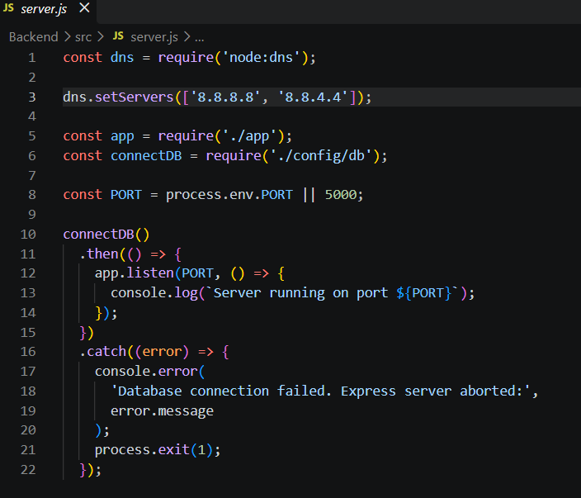

Environment Configuration :
Sensitive configuration details are stored in the .env file instead of directly writing them inside the source code.
Example:
PORT=5001
MONGO_URI = mongodb_atlas
JWT_SECRET=your_jwt_secret
OPENWEATHER_API_KEY=your_openweather_api_key
GEMINI_API_KEY=your_gemini_api

BACKEND REQUEST FLOW
A typical AI WeatherWise API request follows a structured path through the backend:
Client / Postman
↓
Express Server
↓
Route
↓
Middleware
↓
Controller
↓
Service / Model
↓
MongoDB or External Weather / Gemini Service
↓
Controller
↓
JSON Response
↓
Client

This layered request flow keeps responsibilities separated. For example, the controller handles request processing, the model handles database interaction, and the service layer handles communication with external weather or AI services.

5. SECURITY AND CONFIGURATION
Security is considered during the server and backend setup. User passwords are hashed using bcryptjs, JWT is used to protect authenticated routes, and sensitive configuration values are stored in environment variables.
- Passwords are never stored as plain text.
- JWT tokens are verified before protected operations are processed.
- Sensitive API keys and database credentials are kept in the .env file.
- Input validation and sanitization can be applied to reduce unsafe requests.
- Centralized error handling provides consistent API responses.

6. RUNNING THE PROJECT
After completing the setup, the project can be executed using the following steps:
- Open the AI WeatherWise project folder in Visual Studio Code.
- Open the terminal inside the project folder.
- Install dependencies using npm install.
- Configure the .env file with the required values.
- Ensure MongoDB is available.
- Start the backend using the configured npm start command or development command.
- Verify that the server is running on the configured port.
- Test the API endpoints using Postman.
Epic4: Database Configuration

API Testing Demo :

1. Configure MongoDB:

Mongoose was installed in the Node.js backend project using the following command:
npm install mongoose
Mongoose is an Object Data Modeling (ODM) library for MongoDB and Node.js. It allows the application to work with MongoDB using JavaScript objects and schemas.

Create Database connection:
The backend uses the MongoDB URI stored in the .env file to establish a connection with MongoDB Atlas.
Example database connection file: config/db.js
const mongoose = require('mongoose');

const connectDB = async () => {
try {
await mongoose.connect(process.env.MONGO_URI);

console.log(
`MongoDB Connected: ${mongoose.connection.host}`
);
} catch (error) { console.error(
'MongoDB connection error:',
error.message
);
process.exit(1);
}
};
module.exports = connectDB;

Mongoose Schema Definitions
Location Schema:
Defines the structure of location data, including city, country, and associated user.

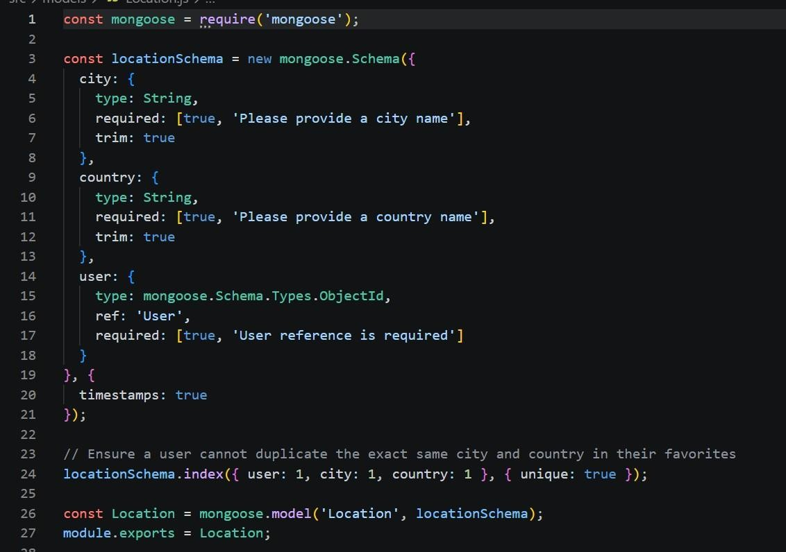

User schema:
Defines the structure of user data, including name, email, and password.
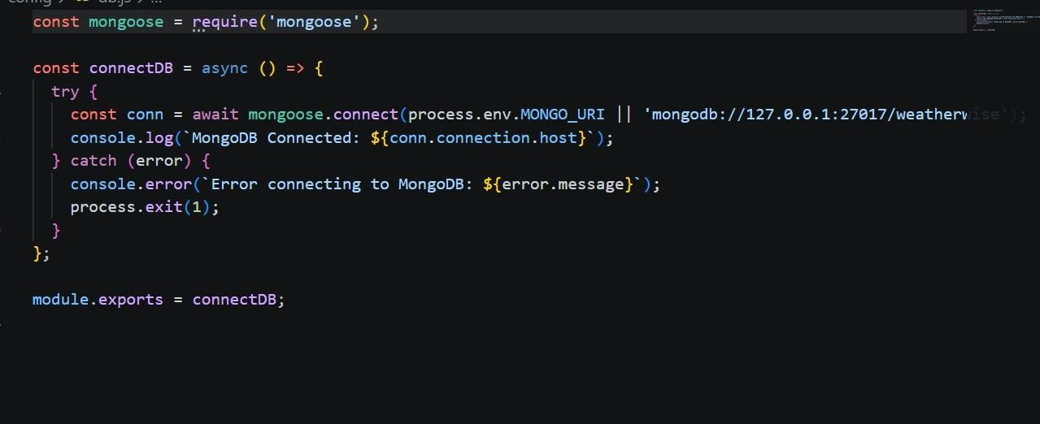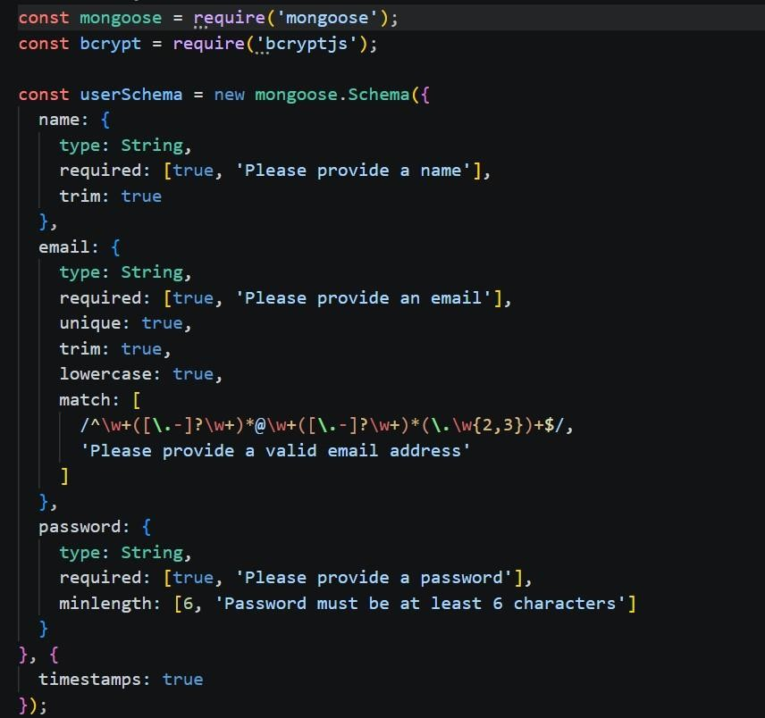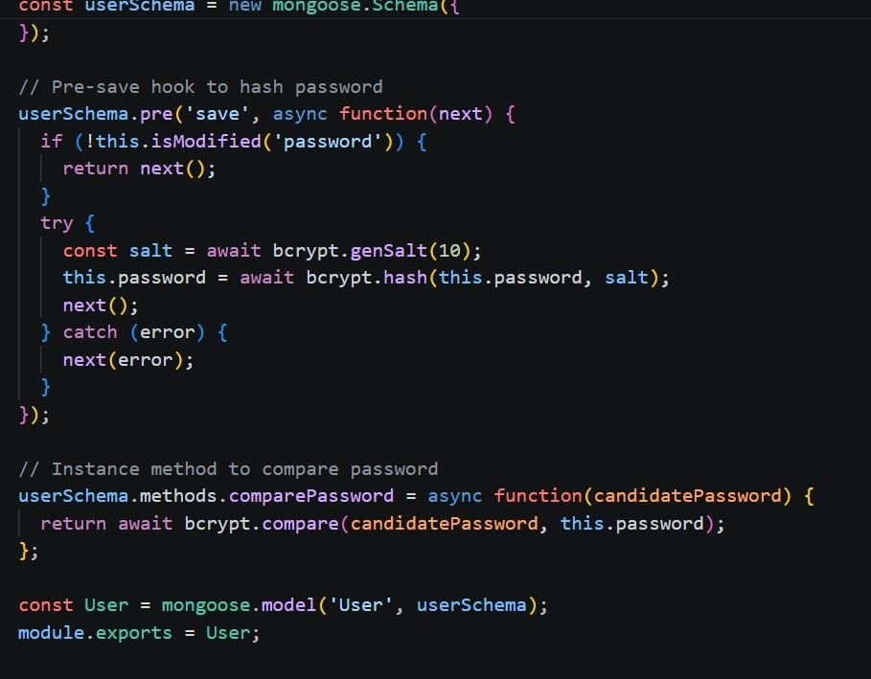

Database Connection:

Establishes a connection between

the Node.js application and MongoDB

using Mongoose. It uses the

MONGO_URI from the environment file

and displays a success message when

the connection is established.

Project Executions

The AI WeatherWise backend can be executed locally using Node.js.

Before starting the application, the following conditions should be satisfied:

* Node.js is installed.
* npm is available.
* Required dependencies are installed.
* MongoDB is available.
* Environment variables are configured.
* Required API credentials are correctly configured where applicable.

Running the Backend Server:
Install all required dependencies:
npm install
Start the development server:
npm start
After successful execution, the server connects to MongoDB and starts listening for incoming API requests.
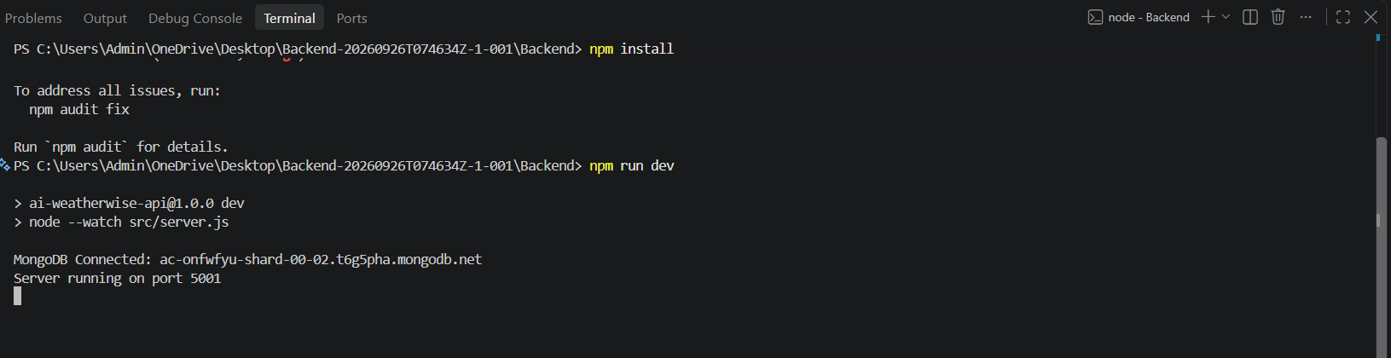
API Testing :

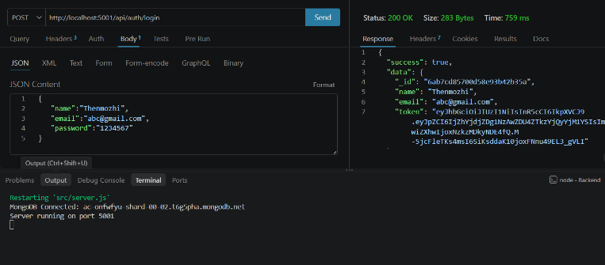
Login API:

Weather Testing:
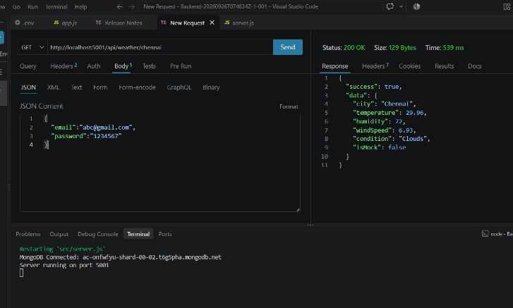

Weather Recommendation :
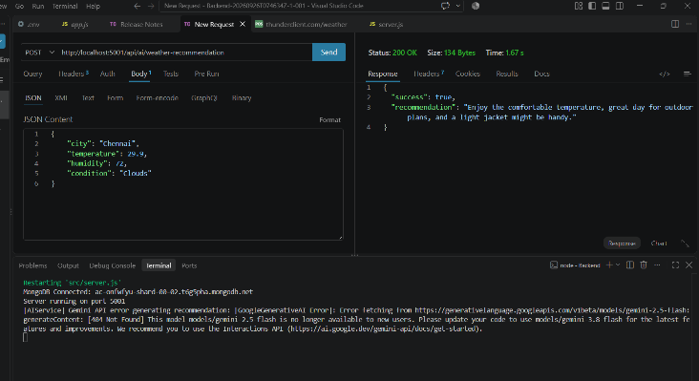

API testing video link: API TESTING .mp4
Demo Video Link: Backend demo.mp4
CodeDrive: Code

